Step1.Click on the java jdk installer file.

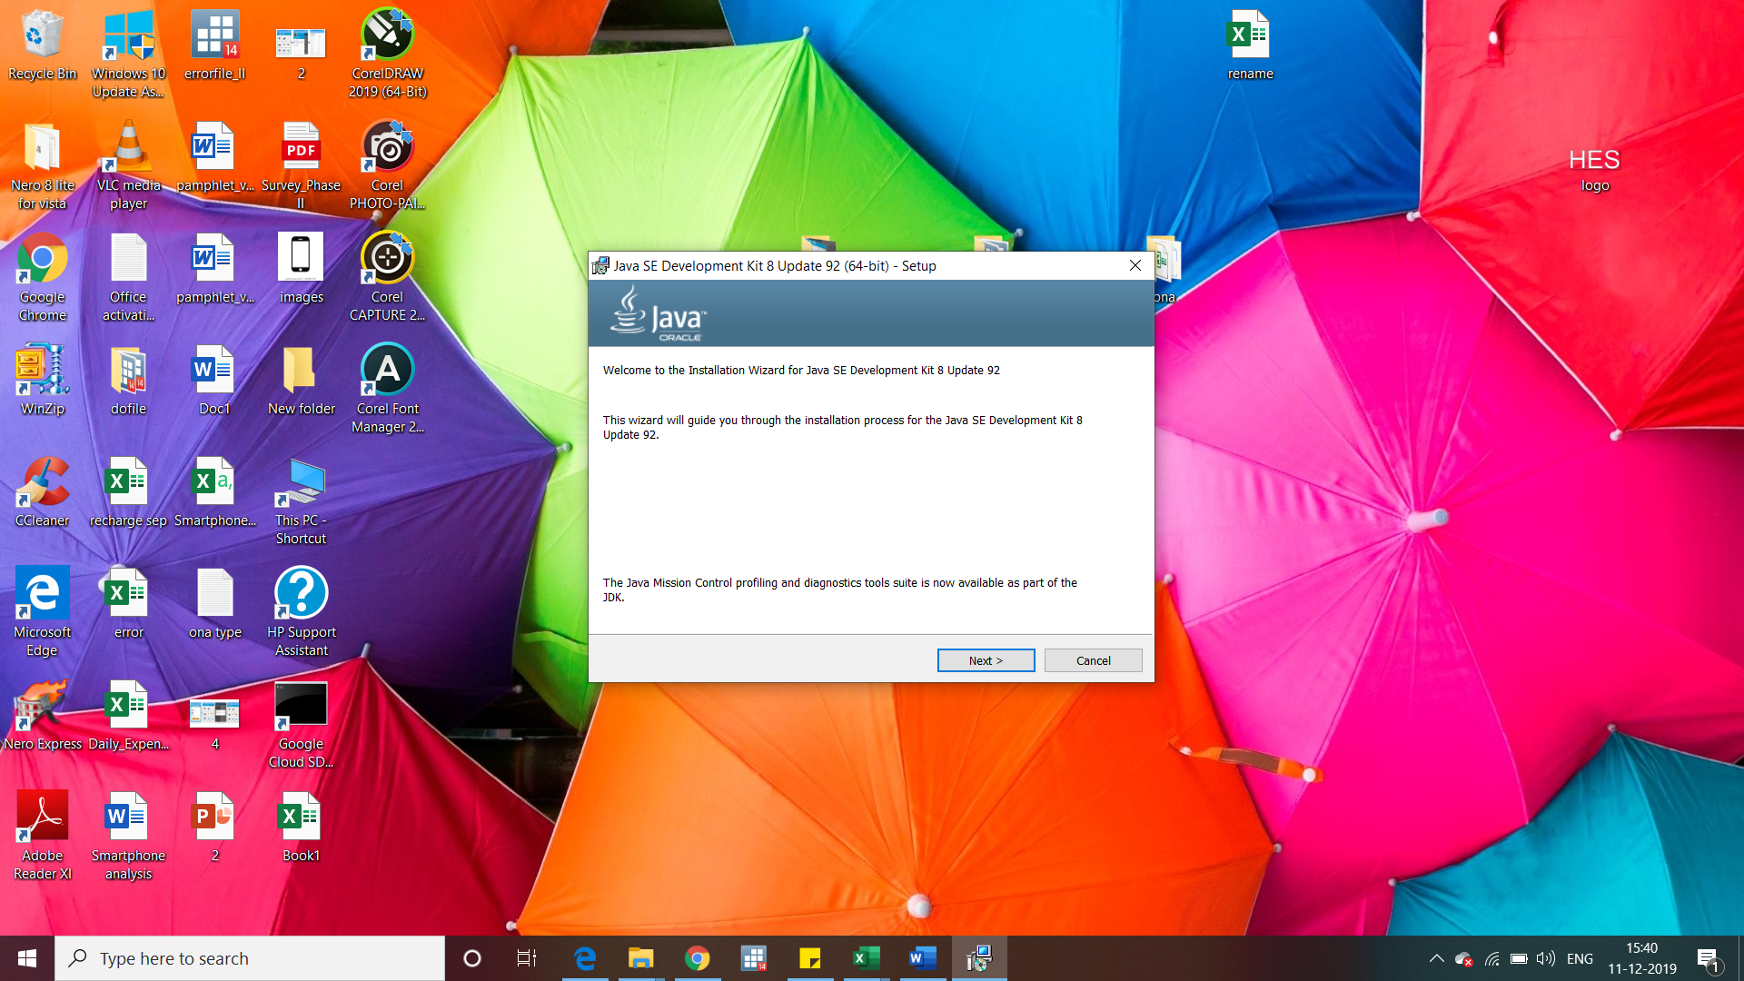

Step2.Select “Development tools” option and click “Next”.

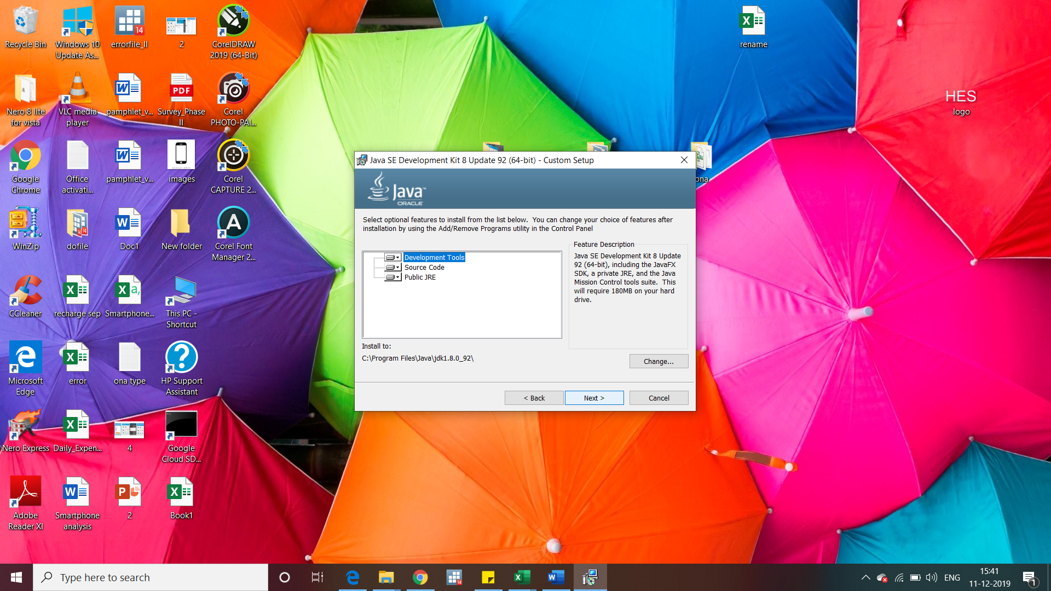

Step3.Java will start installation on the computer.

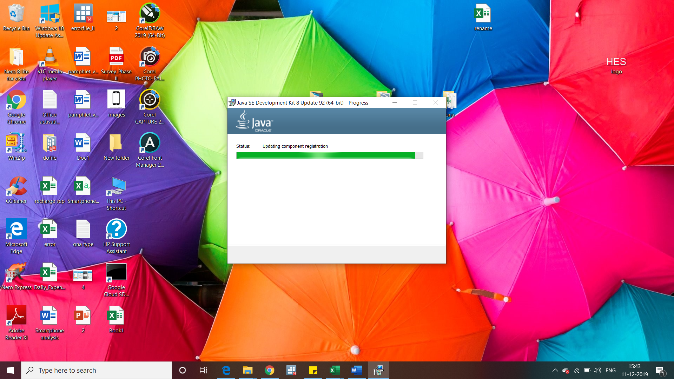

Step4.Click “Next”.

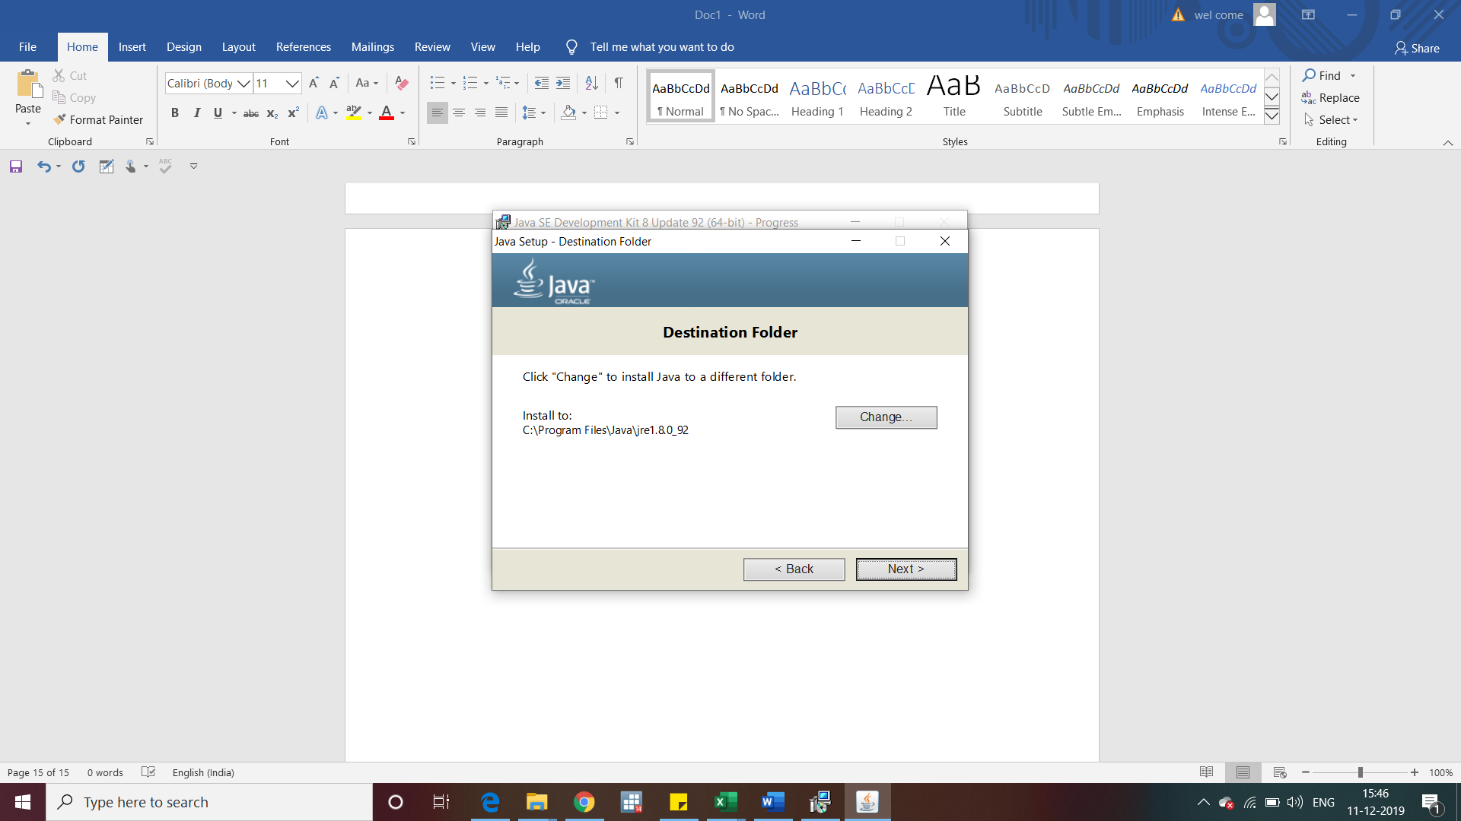

Step5.Installation will take few minutes to complete.

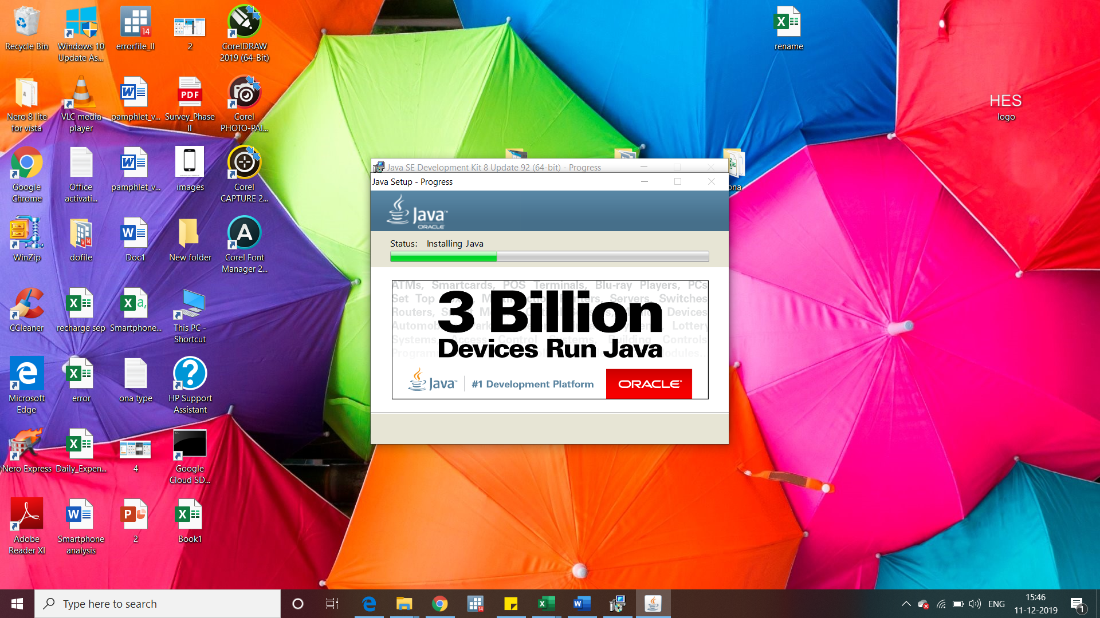

Step6.Click close after completion.

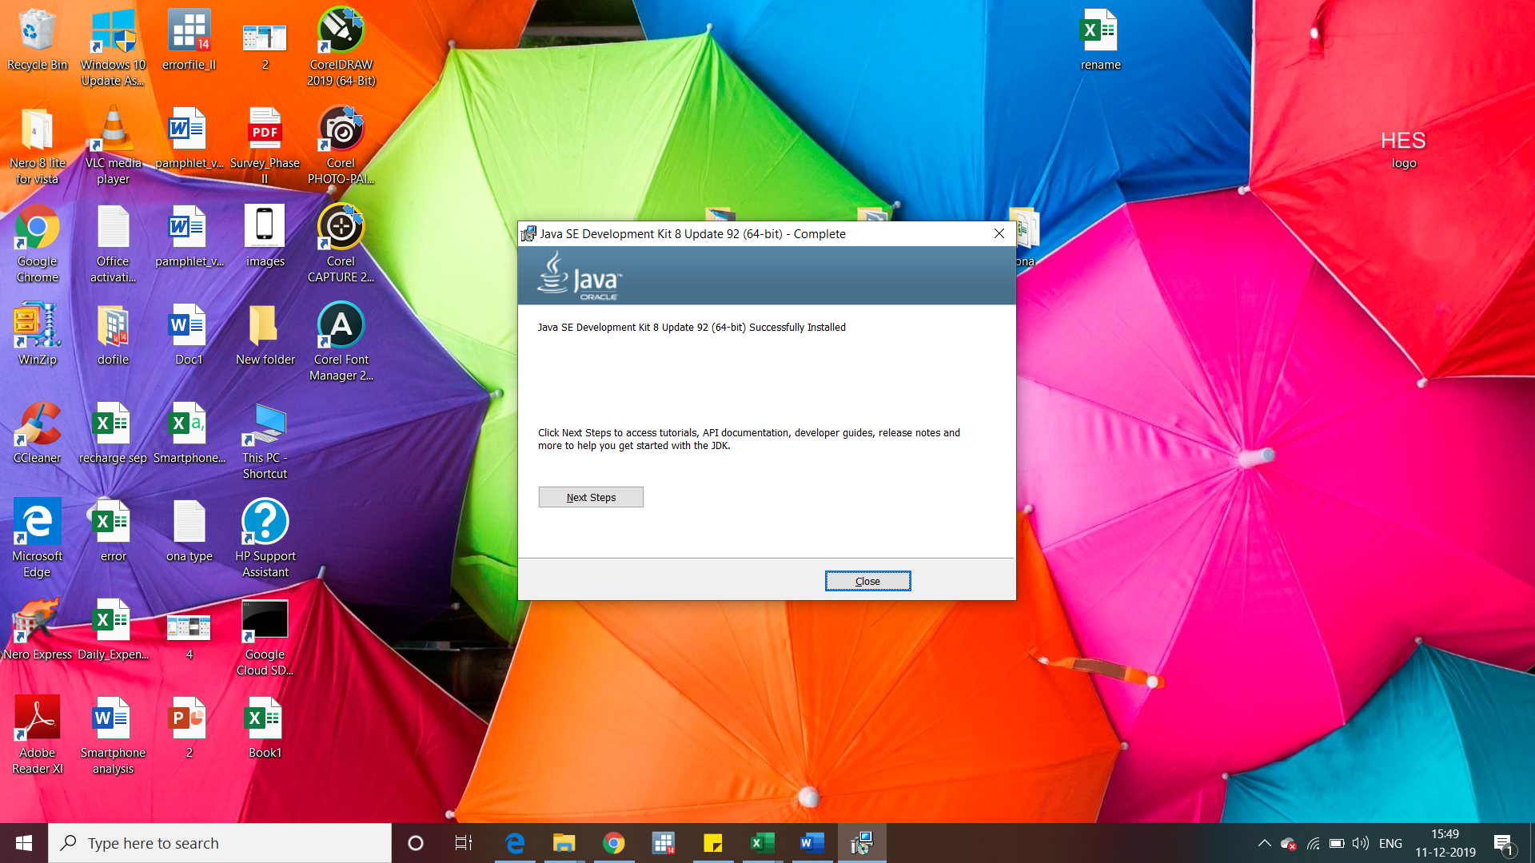

Step7.Click “My computer” go to “C:\Program Files\Java\jdk1.8.0_92\bin” and copy the path.

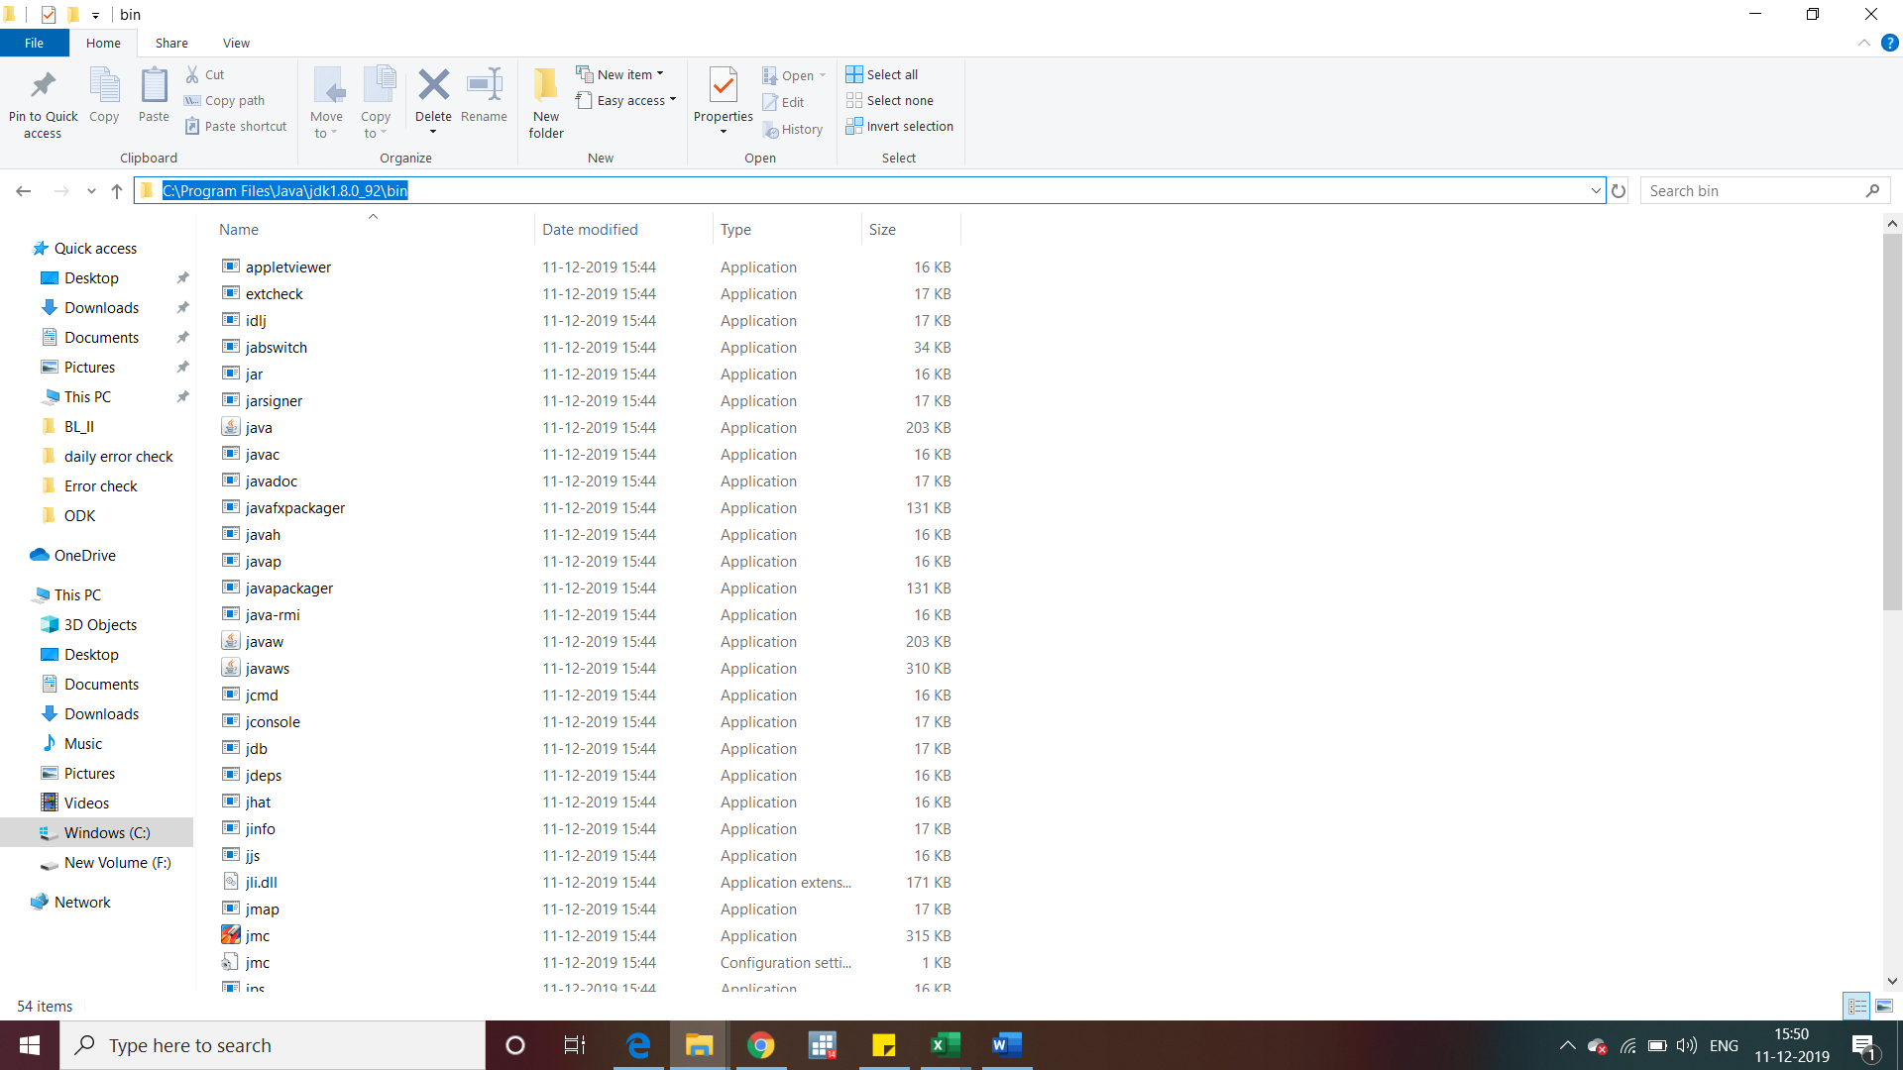

Step8.Go to “MY Computer” and right click select “Properties”.

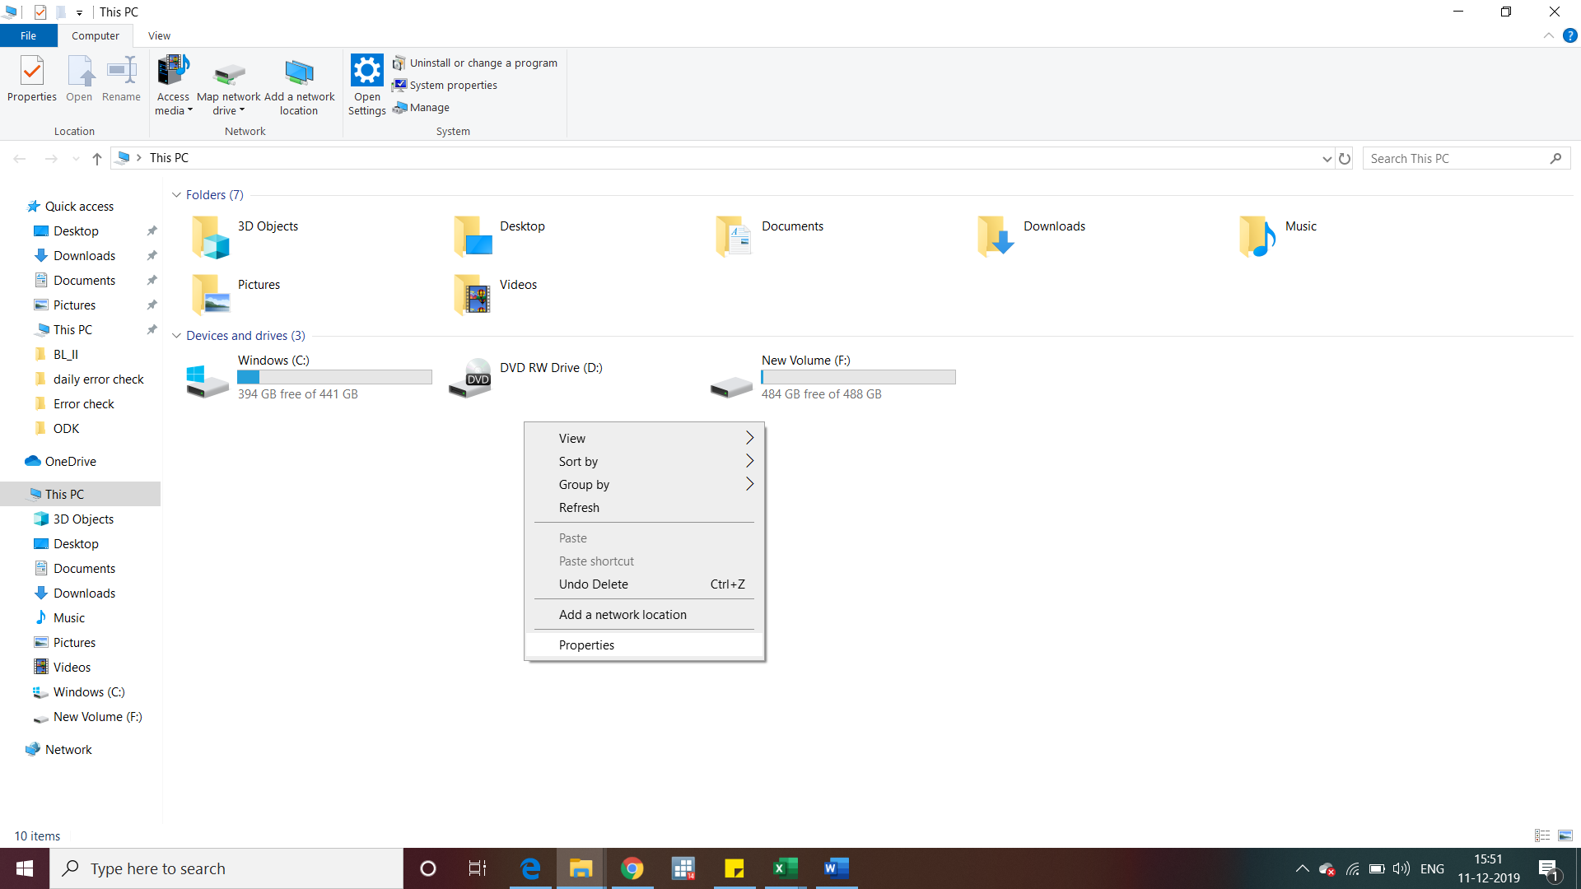

Step9.Select “Advanced System settings”.

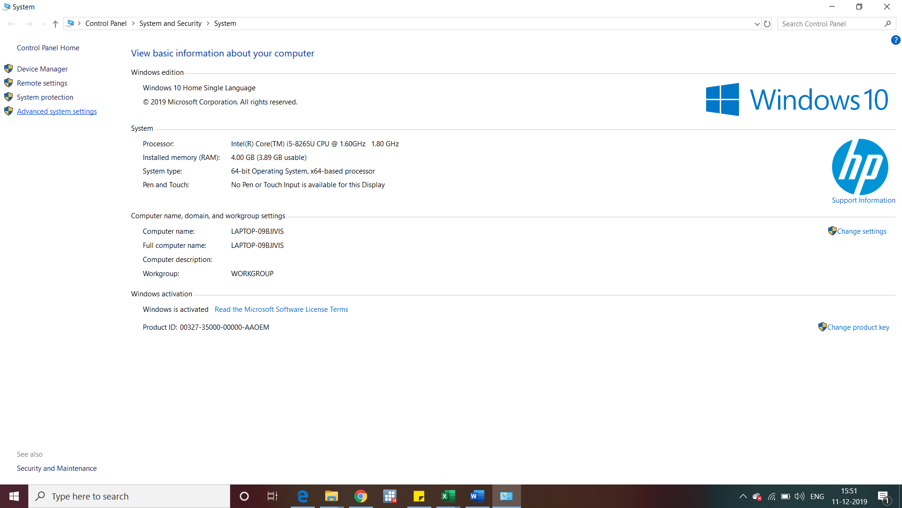

Select10.Select “Environment Variables”.

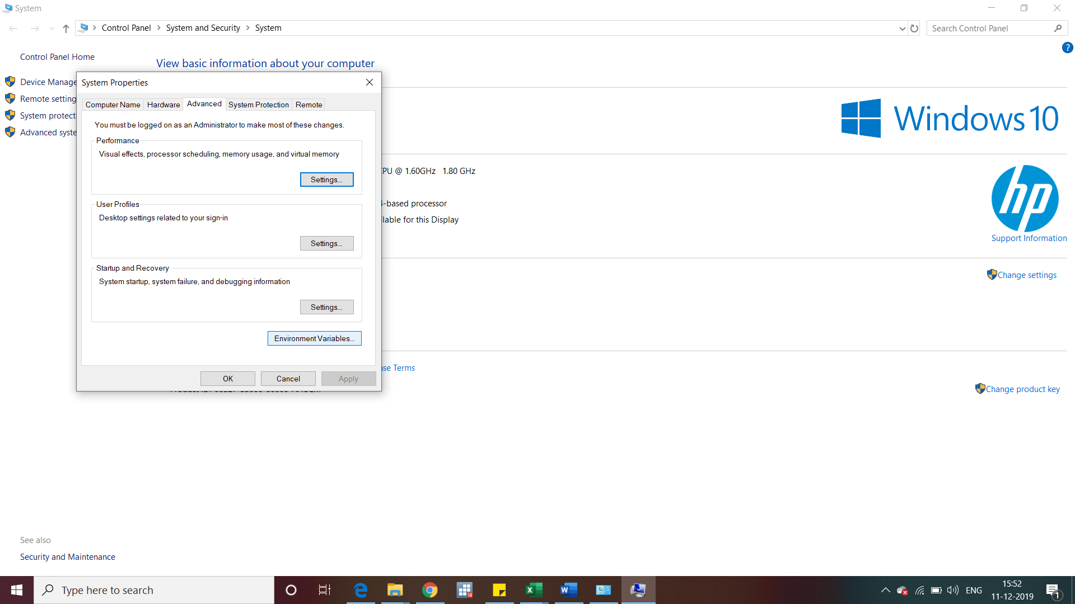

Select11.Select “Path” option and click “Ok”.

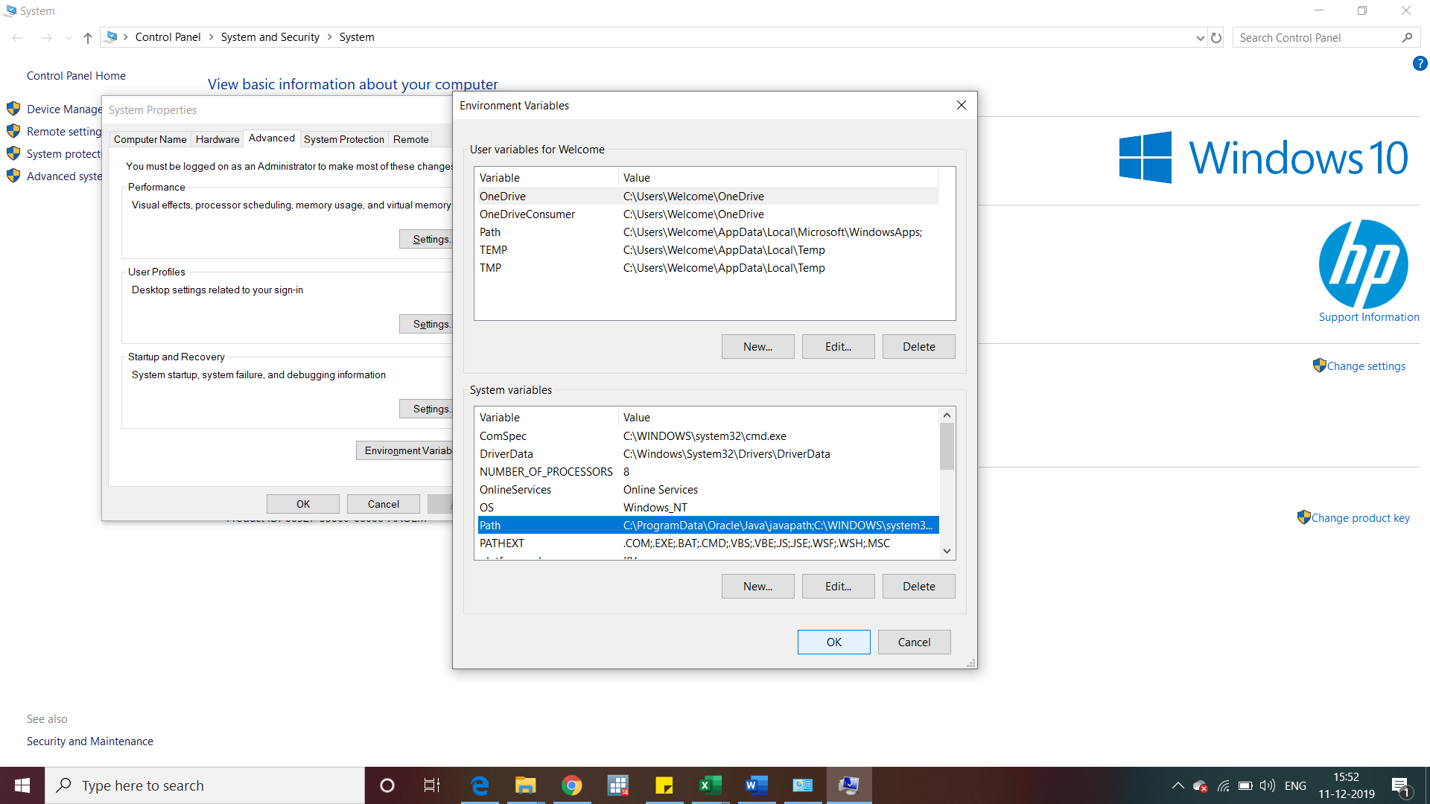

Select12.Click “New” and paste the copied path of java from “step7”.

